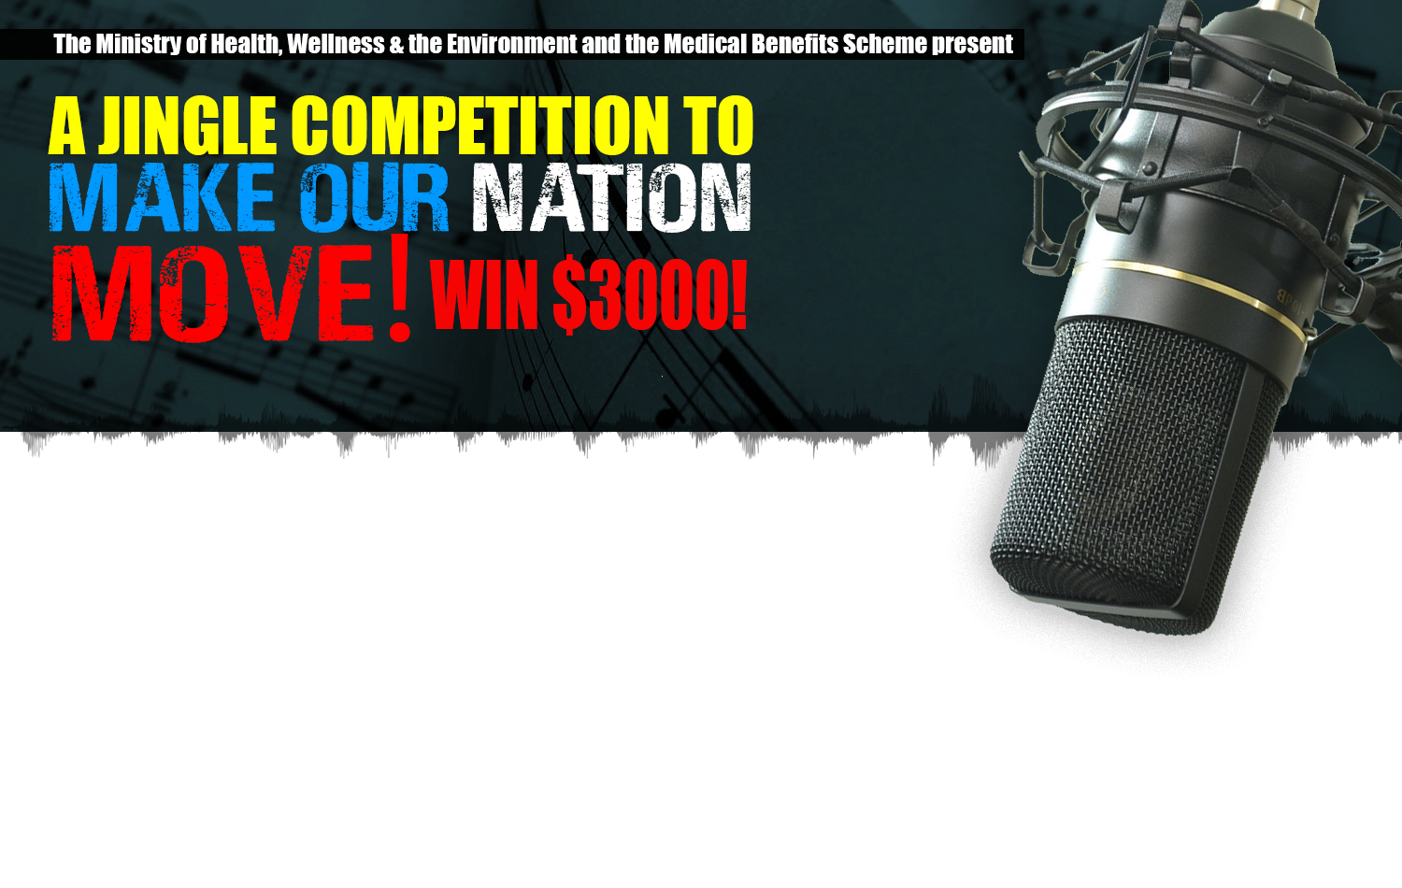

Registration Form

Name:___________________________ Stage Name: ________________________________

Address:_____________________________________________________________________

Contact No: ________________________ Email Address: ____________________________

Date of Submission: ____________________________________________

$3,000 XCD UP FOR GRABS!

Guidelines for messages on Taking Responsibility for your Health
- No Trans fat
- Choose water over sugar sweetened beverages
- Limit the use of salt, salty foods and salty seasonings
- Eat a variety of foods every day
- Include a variety of fruits and vegetables in your daily meals
- Control portion sizes*
- Make physical activity a part of your daily routine

Submit your jingle to the Communications Committee of the Antigua Barbuda Moves
Medical Benefits Scheme, Nevis Street, St. John’s, Antigua or email
PublicRelationsDistributionGroup@mbs.gov.ag

Deadline for Submission: 27th January 2020

