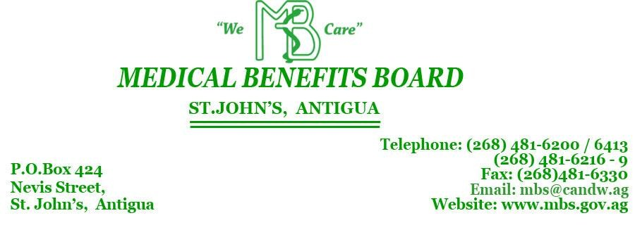

  - APPLICATION FOR DRUGS TO BE INCLUDED IN THE
  - MEDICAL BENEFITS SCHEME FORMULARY

Instructions and guidelines for the preparations of submissions.
1. Please complete one form for each new drug you wish to be included on the Formulary. (The form may be photocopied.)
2. The application should be accompanied where possible by data sheets containing information on the drug and should include side effects, contra-indications, and special precautions.
3. Ideally new drugs added to the Formulary should be therapeutic, cost effective and be used in one of the following eleven diseases: Asthma, Diabetes, Hypertension, Cardiovascular Disease, Certified Lunacy, Sickle Cell Anaemia, Glaucoma, Parkinson’s, Epilepsy, Cancer and Leprosy.
4. Please return to the office of the Director of Pharmacy, at the Medical Benefits Scheme, Nevis Street, St John’s or via email at abovell@mbs.gov.ag . Forms can be faxed to 481-6330.
Doctor’s Name |  | Speciality
Address & Email |  | Telephone
Generic Name |  | Trade Name
Description/Dosage of preparation/Dosage
Name of Supplier of this drug (if known) |  | Unit cost of this Drug (if known)  $ per
How many patients do you propose to treat with this new drug in the next six months?
What amount would you require in the next six months?
Circle the disease that this drug will be used to treat. | - Asthma 2) Diabetes 3) Hypertension 4) Cardiovascular Disease  5) Certified Lunacy 6) Sickle Cell Anaemia 7) Glaucoma  8) Parkinson’s 9) Epilepsy 10) Cancer 11) Leprosy
What drugs are currently on the Formulary with similar actions?
What is the advantage of this new drug?
Should this drug replace any drug or drugs currently on the Formulary?
(Please state the drugs it should replace)
References: (Copies of articles and literature should be included)
Remarks/Additional information
Date of Application |  | Signature:

